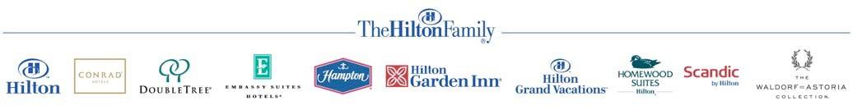

**Credit Card Payment Authorization Form**

***Do not send completed form by email.***

**FAX COMPLETED FORM TO: 793 3273**

**ATTN: Sheldon James**

**Date:**

**HOTEL USE ONLY: -**

Guest / Group Name: **Alex Yu** Check-In / Event Date: **3rd, Sep**

Name of Person/Group Making Reservation: **Natasha Gardner** Phone: **+1 839 638 732**

Authorized Amount: **$4,000** Approval Code:

**CARDHOLDER - Please complete the following section and sign/date below.**

Cardholder Name as it Appears on Credit Card: **Natasha Gardner** Cardholder Billing Address: 270 3rd Street Los Altos 94022

Shipping address: Same as billing address

Daytime /Business Telephone: **+1 839 638 732** Evening Telephone: **+1 839 638 732** Credit Card Number: **6011 1252 2370 9063** Expiration Date: **Jun 2019**

Credit Card Type:

☐ Visa ☐ MasterCard ☐ American Express ☐ Discover ☐ JCB ☐ Diners Club

Credit Card Issuing Bank: **Citi**  Bank Security Number (from back of your credit card): **748**

I agree to cover the following categories of charges: (Please check)

☐ All Charges ☐ Room & Tax ☐ Food & Beverage ☐ Retail ☐ Recreation

I agree to cover the above categories of charges up to a Maximum Amount of $

**Note: Charges for room and tax, group deposits or direct bill account payments will be charged to your credit card immediately. Any incidental charges circled above will be charged at the time of check-out.**

Amount to be immediately charged to credit card for room and taxes or deposit: $

Final Balance Billed to Credit Card (hotel use only): $